
Hospital Management System
Final Year Project



Project Supervisor
Ms. Kainat
Head of Department of Information Technology (IT)
The Islamia University of Bahawalpur

Project Team
Muhammad Hamza
F22BINFT1M01169

Department of Information Technology (IT)
The Islamia University of Bahawalpur

Hospital Management System

By

Muhammad Hamza
Project Submitted to
Department of Information Technology
The Islamia University of Bahawalpur
In Partial fulfillment of the requirements for the degree of

BACHELOR OF SCIENCE
IN
INFORMATION TECHNOLOGY (Honors)

CERTIFICATE OF APPROVAL
Hereby we certify that the above mentioned Final Year Project " Hospital Management System" was done by Muhammad Hamza having Roll No. F22BINFTIM01169 under our supervision and guidance. We have gone through the above mentioned project and found it satisfactory enough for submission for the partial requirement of Bachelors of Science in Information Technology.

Supervisor
Name: Ms.Kainat

Designation : Lecturer (Department of IT)
Signature:
Date: 03/06/2026
External Examiner
Name:
Designation & Organization:
Signature:
Date:

Chairman, Department of Information Technology
Name:
Signature:
Date:
Official Stamp:

Acknowledgement
I would like to express my sincere gratitude to my supervisor, Ms. Kainat, for her constant support, valuable guidance, and continuous encouragement throughout the development of this project. Her insightful suggestions, patience, and expertise played a vital role in the successful completion of my Hospital Management System project. Without her supervision and assistance, the completion of this project would not have been possible.
I would also like to thank all the teachers of the Department of Information Technology for their academic support, knowledge sharing, and guidance during my studies. Their teachings helped me build a strong foundation in web development, programming, database management, and system design.
Finally, I am deeply grateful to my family and friends for their unwavering support, motivation, and encouragement throughout my academic journey. Their continuous support helped me stay focused and successfully complete this project.
Abstract
A Hospital Management System (HMS) is a dynamic, web-based platform designed to provide patients, doctors, and administrative staff with an organized, secure, and user-friendly ecosystem to manage healthcare operations and clinical data efficiently. With the rapid growth of digital transformation in healthcare delivery, modern medical facilities prefer accessing real-time patient analytics, diagnostic tracking, and consultation scheduling through highly responsive, seamless, and interactive web applications. The main objective of this project is to develop a modern, robust, and efficient clinical application that allows patients to easily browse medical specialists, view consultation fees, and register or book appointments dynamically. Simultaneously, the system provides a structured interface where medical practitioners and doctors can review their active consultation queues, track patient histories, and manage digital prescriptions or clinical notes in real time. This project implements a fully PHP-based Hospital Management System that manages and processes critical healthcare metrics dynamically using a secure, database-driven system. The platform enables system administrators to add, update, delete, and manage doctor profiles, patient registration records, and clinical departments through a centralized, protected administrative dashboard. Registered users can access different modules securely and stay updated with their healthcare timelines and appointment validations in real time. The core technologies leveraged for the development of this enterprise project include PHP for robust server-side backend logic and session authentication, MySQL for relational database architecture and secure data management, and HTML5, CSS3, JavaScript, and Bootstrap frameworks for crafting an interactive, cross-device responsive frontend design. The entire codebase is compiled and developed utilizing Visual Studio Code (VS Code) and runs locally within a simulated server environment via the XAMPP cross-platform stack. The system architecture is engineered to provide fast performance, highly secure session handling, easy navigation, and a fluid responsive layout for an enhanced user experience across desktops, tablets, and smartphones. This project successfully aims to eliminate the latencies, data redundancies, and security gaps inherent in manual paper ledger systems, creating an informative, secure, and reliable digital platform that delivers medical administrative workflows efficiently and effectively.

Keywords: Hospital Management System; HMS; PHP; MySQL; Web Application; Clinical Dashboard; Healthcare Portal; Appointment Booking System; Patient Profiling; Role-Based Authentication; Relational Database; XAMPP; HTML; CSS; JavaScript; Bootstrap Framework.

Table of Contents
1.1 Introduction 7
1.2 Background 7
1.3 Research Problem 7
1.4 General Objectives 8
1.5 Specific 8
1.6 Justification 8
1.7 Scope of the Project 8
Chapter 2 10
2.1 Introduction 10
2.2 Current Situation 10
2.3 Challenges Experienced 10
1. Medical Record and Scheduling Management Problems 10
Chapter 3 12
System Development Methodology 12
System Design and Methodology 12
3.1 System Methodology 12
3.2 Evolutionary Prototyping Model 12
3.2.1 Requirements Analysis and Specification 12
3.2.2 Prototype Design 12
3.2.3 Customer / Supervisor Valuation 12
3.2.4 Prototype Building 13
3.2.5 Prototype Testing 13
3.2.6 Justification of Methodology 13
3.2.7 Functional Requirements 13
3.3.1 Administrative Operations 14
3.3.2 Non-Functional Requirements 14
3.3.2.1 Usability Requirement 14
3.3.2.2 Reliability Requirement 14
3.3.2.3 Data Integrity Requirement 14
3.3.2.4 Security Requirement 15
3.5 Proposed Module and Architecture 15
3.5.1 User Module 15
Chapter 4 17
System Design and Analysis 17
4.3 Methodology and Setup of Experiment 18
EER Diagram 23
ER Diagram 24
4.8Flow Chart 24
Chapter 5 27
Conclusion and Recommendations 27
5.1 Summary of the Objectives 27
5.3 Recommendations 28

1.1 Introduction
The Hospital Management System (HMS) is a web-based platform developed to provide patients, doctors, and administrative staff with easy access to automated healthcare scheduling, digital prescription tracking, and centralized patient data logs. In today’s digital era, automated healthcare information systems have become one of the fastest and most efficient sources for managing institutional clinical operations and workflow data. This project is designed to deliver dynamic, real-time medical scheduling and administrative management through a user-friendly interface using PHP and MySQL technologies.

1.2 Background
With the rapid growth of digital healthcare services, patients and medical facilities now prefer online management platforms over traditional manual paper filing and physical appointment booking systems. While some medical centers utilize basic software setups, administrators and patients often face critical issues such as slow database performance, poor user interface design, and outdated or non-synchronized tracking information. Therefore, there is an urgent need for a highly responsive and efficient web application that can manage, secure, and display clinical scheduling, doctor availability, and patient diagnostic records effectively. This project aims to fulfill that structural need by creating a modern web application with optimized backend accessibility and a seamless user experience.

1.3 Research Problem
Traditional methods of managing clinical records, patient profiling, and doctor appointment scheduling through manual paperwork or physical ledger sheets are highly inefficient compared to modern web-based applications. Many existing medical administrative setups lack proper centralized database management, real-time availability updates, and well-organized data categories for different user roles. Additionally, standard legacy platforms are often not mobile-friendly and fail to provide a smooth, cross-device browsing experience for remote patients. The main problem addressed in this project is the development of a dynamic, highly secure, and responsive system that can efficiently manage, store, and display doctor queues, scheduling availability, and patient profiles for users in a simple, organized, and attractive way.

1.4 General Objectives
The main objective of this project is to develop a dynamic and secure Hospital Management System (HMS) using PHP and MySQL that provides patients, doctors, and administrative staff with real-time scheduling updates, digital prescription tracking, and centralized healthcare records through an interactive, role-based, and user-friendly platform.
- To design and develop a highly responsive web interface for managing clinical appointments and user registration logs seamlessly across multiple devices.
- To create a secure and robust administrative panel for managing doctor profiles, patient clinical records, and departmental scheduling categories efficiently.
- To store, index, and retrieve medical data, biometric attributes, and real-time transaction history entries efficiently using a structured MySQL database.
- To provide different user groups (Patients, Doctors, and Admins) with easy dashboard navigation and smooth directory switching via secure session management.
- To improve overall user engagement, minimize operational latencies, and prevent scheduling friction through an attractive, intuitive frontend user interface built on Bootstrap

1.5 Specific

1.6 Justification
This project is highly important because it provides a centralized online clinical platform where patients can access healthcare services, check doctor schedules, and request appointments anytime and anywhere. It significantly improves digital communication and information sharing within a medical facility while completely reducing dependence on traditional paper-based media sources. The system also allows administrators to manage doctor onboarding and patient logs easily and efficiently, making it perfectly suitable for modern clinical environments.

1.7 Scope of the Project
The scope of this project includes the development of a web-based Hospital Management System with features such as real-time appointment booking, dynamic department management, digital prescription archives, and an admin control panel. The system is focused on secure data entry, role authentication, and user viewing functionalities. It is developed using PHP, MySQL, HTML, CSS, JavaScript, and Bootstrap frameworks, and is fully intended to run on a local server environment such as XAMPP.

Chapter 2

2.1 Introduction
Requirements analysis is an important phase in system development that helps identify the absolute needs, boundaries, and functionalities of the proposed healthcare system. This chapter explains the precise requirements of the Hospital Management System, including the current situation of clinics, challenges faced in manual medical setups, and the specific software technologies required for the execution of the project.

2.2 Current Situation
Currently, many local clinics and small hospitals still rely on manual filing systems or standalone spreadsheets to manage patient records and scheduling sequences. Existing legacy frameworks often struggle to provide synchronized medical data, track ongoing doctor availability, or handle billing operations smoothly. In most cases, patients experience high waiting times, and front desk operators struggle with double-booking conflicts, which heavily affects the overall user experience and quality of healthcare.

2.3 Challenges Experienced

1. Medical Record and Scheduling Management Problems
Many existing healthcare websites and legacy systems face significant difficulties in managing large amounts of sensitive patient files, clinic schedules, and electronic health records. Updating available doctor consultation slots, clinical departmental categories, and profile records manually can be extremely time-consuming, error-prone, and inefficient for hospital administrators.
2. Poor User Experience
Some existing healthcare portals have complex layouts, slow database performance, and non-responsive designs that make it difficult for patients and medical staff to browse schedules or manage records smoothly on mobile devices and computer workstations.
3. Lack of Security
Existing clinical systems may not provide proper security and encryption mechanisms to protect sensitive patient health data and admin dashboard accounts. Weak or non-existent authentication systems can lead to unauthorized access, data breaches, and illegal medical data manipulation.
4. Limited Search and Navigation
Patients and staff members sometimes struggle to find specific specialized doctors or check dynamic fee matrices because of poor search functionality and unorganized clinical departmental categories.
5. Maintenance and Performance Issues
Traditional, legacy medical websites and local setups may become slow when handling large amounts of historical patient data, daily appointment traffic, and concurrent query logs. Maintaining and updating such database tables can also become extremely difficult without a proper structured relational management system.

Chapter 3

System Development Methodology

System Design and Methodology

3.1 System Methodology

System methodology refers to the processes and techniques used to develop the Hospital Management System. For this project, the Evolutionary Prototyping Model is used because it allows continuous improvement of the system based on supervisor feedback and clinical requirements. This methodology helps in developing a flexible, secure, and user-friendly medical platform step by step.

3.2 Evolutionary Prototyping Model
The Evolutionary Prototyping Model is a software development approach where the system is developed gradually through different versions or prototypes. Each prototype is improved based on structural testing and user role evaluations until the final system is completed. This model is highly suitable for healthcare web applications because it helps identify clinical data management problems early and improves overall system quality.

3.2.1 Requirements Analysis and Specification
In this phase, the healthcare system requirements are identified and analyzed. The functional and non-functional requirements of the Hospital Management System are gathered to understand the precise needs of patients, doctors, and administrators. Features such as patient profiling, real-time appointment booking, medical prescriptions tracking, and secure admin dashboard controls are strictly defined in this stage.

3.2.2 Prototype Design

During the prototype design phase, the layout and structure of the medical portal are created. User interfaces such as the patient registration forms, doctor specialization catalogs, fee matrices, and administrative dashboard panels are designed using HTML, CSS, and Bootstrap to provide a clean, accessible, and professional user experience.

3.2.3 Customer / Supervisor Valuation
In this phase, the project supervisor evaluates the developed prototype to provide feedback regarding the clinical system design, data flows, and usability. Her insightful suggestions help improve the functional modules and user access roles of the hospital application before final implementation.

3.2.4 Prototype Building

The approved prototype is developed into a fully working healthcare system using PHP and MySQL. Core backend functionalities such as secure database connectivity, dynamic data querying, patient booking validation engines, and administrative content moderation operations are implemented during this stage.

3.2.5 Prototype Testing
Testing is performed to ensure that the healthcare application functions correctly, securely, and efficiently. Different tests such as structural functionality testing, cross-device usability testing, and backend session validation testing are conducted to identify and resolve query logic errors within the local XAMPP server environment.

3.2.6 Justification of Methodology
The Evolutionary Prototyping Model is selected because it allows continuous improvement and flexibility during the software development life cycle. It helps align system logic directly with clinical workflows, ensures requirements are met clearly, and reduces the chances of system failure by testing active prototypes at different development stages.

3.2.7 Functional Requirements
Functional requirements describe the core operational workflows and data actions of the clinical platform. These include:
- Secure administrator login, password validation, and dashboard authentication.
- Dynamic capability to add, edit, and delete doctor profiles, scheduling records, and consultation fees.
- Management of clinical departments and specialization categories.
- Real-time display of active doctor queues, availability status, and patient history logs.
- Advanced search functionality to filter doctors by name, fee matrix, or specialization field.
- Fully responsive frontend interfaces matching user viewpoints across multiple devices.
3.3 Authentication
Authentication mechanisms are implemented to provide highly secure access boundaries to the restricted administrative and clinical sections of the portal. Only authorized users with verified active sessions can log in to manage health data records and perform administrative workflows.

3.3.1 Administrative Operations
The administrative module allows the system administrator to manage all core activities of the medical portal. The admin can onboard doctors, update clinic timings, remove outdated appointment records, manage department listings, and monitor user registration data metrics through a centralized, secure dashboard layout.

3.3.2 Non-Functional Requirements
Non-functional requirements describe the quality, constraints, and operational performance characteristics of the system.

3.3.2.1 Usability Requirement
The healthcare platform must be highly user-friendly, intuitive to navigate, and accessible for users with varying levels of technical skills. The entry forms should have simple verification layouts and a fluid responsive design.

3.3.2.2 Reliability Requirement
The system must operate efficiently under routine database loads without application crashes or technical downtime, providing accurate diagnostic data display and stable SQL operations.

3.3.2.3 Data Integrity Requirement
The database schema must enforce strict relational parameters ensuring all stored medical metrics, patient appointment lines, and doctor data logs remain accurate, normalized, consistent, and protected from accidental loss or unauthorized modifications.

3.3.2.4 Security Requirement
The web application must use protected session tokens, secure account verification layers, and sanitized input validation routines to block unauthorized route access and protect backend data strings against common web exploits such as SQL injection.

3.5 Proposed Module and Architecture
The proposed healthcare system is broken down into distinct, specialized structural modules that interact with the central relational database engine to provide automated hospital administration workflows.

3.5.1 User Module
The user module allows visitors to browse news articles, entertainment content, categories, and multimedia information. Users can search and read content easily through the frontend interface.
3.5.2 Administrative Module
The administrative module provides a highly secure control panel where the system admin manages all core clinical platform content, including onboarding doctor profiles, updating appointment slots, and auditing user registration data records.
3.5.3 Security Module
The security module handles strict session authentication, input data sanitization, and verification features to protect the healthcare platform from unauthorized entry, data breaches, and common web security threats.
3.6 System Development Tools and Techniques
3.6.1 HTML
HTML is used to create the fundamental layout structure, input forms, and data display pages in the Hospital Management System web application.
3.6.2 PHP
PHP is used as the server-side backend programming language to develop dynamic clinical functionalities, handle role-based user sessions, and connect the web application securely with the database.
3.6.3 JavaScript
JavaScript is used to add client-side validation for booking forms, dynamic front-end interactions, and responsive UI elements to improve the overall patient experience on the portal.
3.6.4 MySQL
MySQL is used as the relational database management system to store, index, and organize structural healthcare content such as patient credentials, doctor specialized profiles, and appointment tracking tables.
3.6.5 IDE
Visual Studio Code (VS Code) is used as the Integrated Development Environment (IDE) for compiling code files, debugging backend logic, and managing the overall project folder architecture.
3.6.6 Case Studies
Different online clinical management systems, electronic healthcare portals, and medical scheduling web applications were studied to understand modern relational design, data optimization techniques, and multi-user role management workflows. These case studies helped in improving the functional layout and overall system security of the proposed Hospital Management System.

Chapter 4

System Design and Analysis
4.1 Functional Requirements
Functional requirements describe the main features and operations of the Hospital Management System. The system should allow administrators, doctors, and patients to securely log in and manage clinical activities and data workflows efficiently. Admin users can add, edit, update, and delete doctor profiles, specialized clinical fields, and medical department categories. The system should display real-time doctor availability queues, appointment validation updates, and digital health statuses to logged-in users. Users should also be able to browse different clinical fields, search for specific specialists by name or fee criteria, and access patient history summaries through a responsive and user-friendly dashboard interface.
4.2 Non-Functional Requirements
Usability
The system should be simple, user-friendly, and easy to navigate for all patient groups and medical personnel. The medical web portal interface should provide clear dashboard panels, organized appointment categories, and responsive patient booking forms to improve the user experience on both desktop workstations and mobile screens.
Performance
The system should load pages quickly and display clinical dashboards and healthcare tracking lists efficiently with minimal delay. Relational database operations, execution queries, and server actions should be optimized for faster healthcare records data retrieval.
Supportability
The hospital application should run smoothly on different digital devices, local operating systems, and mainstream web browsers without compatibility friction. The backend codebase should also be easy to maintain and update when scaling or adding advanced electronic prescription features in the future.
Reliability
The system must provide accurate and consistent relational functionality while displaying database metrics and tracking diagnostic schedules. It should operate continuously under simulated administrative server loads without database crashes or critical transaction errors. Confidential patient records, appointment profiles, and administrative credentials must be protected using verified session authentication methods and strong data validation checks. The application must block unauthorized URL bypass routing and prevent common web security vulnerabilities such as SQL injection exploits and data manipulation.

4.3 Methodology and Setup of Experiment
The Hospital Management System is developed using PHP, MySQL, HTML, CSS, and JavaScript technologies. The project follows the Evolutionary Prototyping Model, where the system is developed and improved gradually through structured testing and supervisor feedback. The frontend interface is designed using HTML, CSS, and Bootstrap frameworks to ensure responsive layouts, while PHP is used for server-side backend development, role-based session handling, and relational database connectivity.
The system is implemented using Visual Studio Code as the core development environment (IDE) and XAMPP as the local cross-platform server platform. MySQL is used to store, index, and manage structured healthcare data such as patient credentials, doctor profiles, clinical department categories, and appointment tracking tables. Various validation tests are performed locally to ensure proper functional workflow, cross-device responsiveness, session security, and database performance of the system before final verification.
4.4 Hospital Management System Literature Review Matrix

Paper Title and Author | Introduction | Methodology | Tools and Technologies | Conclusion | Future Scope
Online Clinic Portal System (Khan, A., et al. 2021) | The study focuses on developing an online clinical portal for delivering fast and updated healthcare scheduling access to users. | The system uses a web-based 3-tier architecture with dynamic patient data management and database integration. | PHP, MySQL, HTML, CSS, JavaScript, and XAMPP. | The system successfully provides efficient patient management and improves user accessibility to online healthcare. | Future improvements include mobile applications, automated notification queues, and live chat updates.
Medical Center Management System (Ali, M., et al. 2020) | This research focuses on creating an integrated healthcare website for sharing doctor profiles, timetables, and medical categories. | The system implements responsive web design and database indexing techniques for smooth patient and staff interaction. | PHP, Bootstrap, JavaScript, and MySQL database. | The system improves overall user engagement and provides organized clinical schedule structures. | Future work includes advanced telemetry tool integration and personalized health recommendations.
Dynamic Hospital Website Using PHP (Sharma, R., et al. 2019) | The study aims to develop a dynamic website that allows administrators to manage records and publish active doctor schedules online. | The methodology includes responsive frontend design, server-side backend programming, and core database connectivity. | PHP, MySQL, HTML, CSS, and JavaScript. | The website provides efficient medical profiling management and easy access to updated clinical operations information. | Future enhancements include multilingual support channels and secure cloud hosting services.
AI-Based Patient Health System (Hussain, F., et al. 2022) | This system focuses on improving user experience by scheduling relevant doctors and analyzing medical data logs using artificial intelligence algorithms. | Patient consultation history and specialized timelines are analyzed using systematic database matching scripts. | Python, Machine Learning engines, MySQL, and Web APIs. | The system improves overall healthcare management through structured data analysis and predictive scheduling flows. | Future scope includes deep learning predictive diagnostic modules and real-time appointment validation tracking.
Real-Time Healthcare and Booking Platform (Ahmed, S., et al. 2023) | The research develops a real-time web portal for delivering urgent medical appointments and structural schedule updates to remote users. | The platform integrates dynamic web modules with cross-device responsive interfaces and relational database management. | PHP, JavaScript, MySQL database, AJAX scripts, and Bootstrap. | The system improves healthcare data delivery speed and reduces administrative queue friction points. | Future enhancements include native mobile application integration and advanced cryptographic security mechanisms.

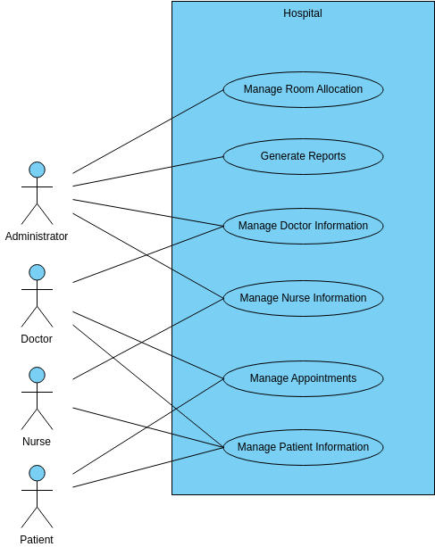

EER Diagram

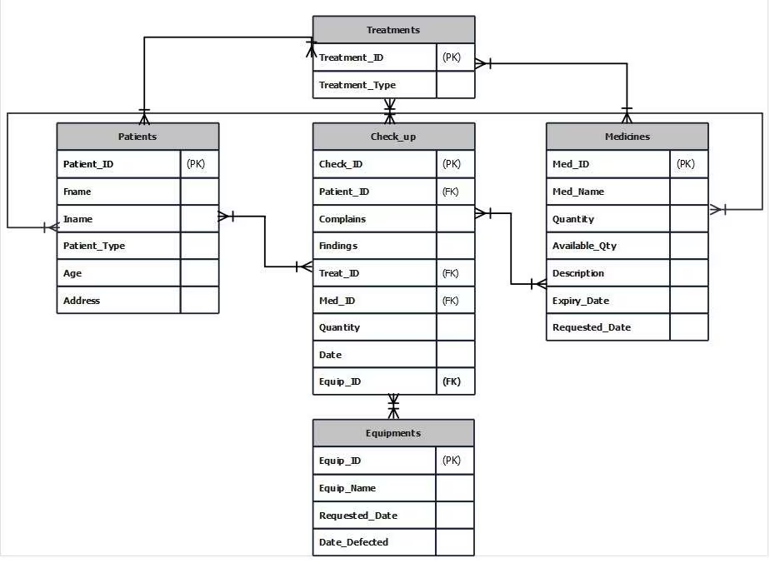

ER Diagram

4.8Flow Chart

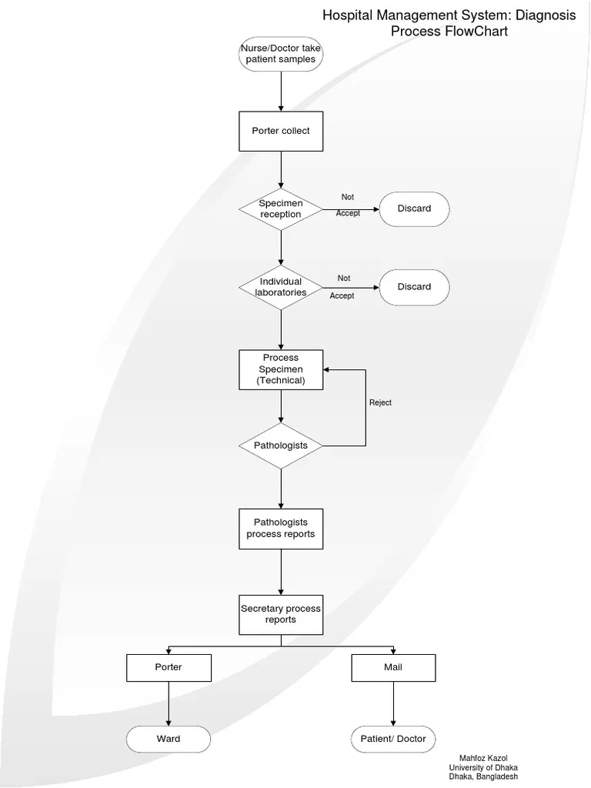

4.9 Future Directions
- The system can be further improved by integrating automated SMS and email notification gateways to instantly alert patients about booking confirmations and queue updates.
- Dedicated mobile applications for both Android and iOS platforms can be developed to increase user accessibility and allow on-the-go appointment tracking.
- An AI-based diagnostic chatbot can be added to guide patients during initial triage, check general doctor schedules, and provide quick assistance regarding clinic timings.
- Telemedicine and video-consultation modules can be implemented inside the system, enabling remote prescription handling and live digital checkups.
4.10 Conclusion
The Hospital Management System is a web-based clinical portal developed using PHP, HTML, CSS, JavaScript, and a MySQL relational database backend. The system enables patients to look up professional specialists, check operational fee matrices, and automatically log appointment entries through a secure scheduling architecture. It provides a clean and highly user-friendly dashboard layout where hospital administrators can seamlessly onboard doctors and audit dynamic patient data files.
The portal significantly contributes to optimizing medical facility operations by completely reducing manual booking friction and human layout errors. It plays an important role in enhancing hospital administrative coordination, improving clinic resource utilization, and driving data-driven health record management in digital hospital setups.
4.12 Testable Requirements
System testing is an essential phase used to verify the functional workflows, data accuracy, and transaction performance of the developed Hospital Management System. It ensures that the database query strings execute correctly according to the defined multi-user roles and produce reliable operational results under local server loads.
Unit Testing
This level of testing focuses on validating individual component scripts, such as direct database connection paths, input form field sanitization routines, login session verifications, and custom dashboard view parameters. Each backend module is tested separately to block system errors early.
Integration Testing
This testing phase verifies the structural interaction between different system layers, including the native PHP backend server logic, structural MySQL data constraints, XAMPP local execution routing, and the active frontend Bootstrap layout. It ensures smooth data flow and accurate primary-to-foreign key communication between database tables during record insertion.
System Testing
The complete hospital application is tested as a unified setup to confirm that all functional appointment logs and non-functional security or response benchmarks are fully satisfied before deployment.
Acceptance Testing
This testing is performed from the end-user perspective (including mock actions by administrators, doctors, and patients) to ensure the system matches real-world medical center workflows. Users validate whether the platform correctly handles continuous booking changes and maintains data integrity logs before formal deployment approval.

Chapter 5

Conclusion and Recommendations

5.1 Summary of the Objectives
This project focuses on the development of a Hospital Management System that provides structured multi-user portals and centralized administrative functionalities. Users are able to register accounts, log in securely, browse specialist doctor listings, and input patient details to book dynamic appointment slots. The system utilizes a structured PHP backend integrated with a MySQL database architecture to process, store, and manage clinic scheduling queues in real time.
The system successfully achieved all of its defined academic and operational objectives. It allows remote patients to search for medical specialists, receive instant booking validations, and track their consultation history logs seamlessly. Additionally, the system indexes patient allocation rows for future clinical audits, improving database tracking and institutional usability. The administrative control module provides extensive data management over doctor onboarding profiles and clinic departmental categories. Overall, the system completely removes manual clinical booking errors and improves medical center management efficiency.
However, some environmental constraints were handled during development, including the simulation of concurrent patient queries on a local workspace and configuring data entry validation limits for complex medical logs. Furthermore, the current web prototype is configured within a localized network environment using the XAMPP platform and requires proper integration with active live servers for wider cloud deployment.
5.2 Conclusions
The primary goal of this project was to design and implement an automated web application for managing hospital administration workflows and doctor appointments using PHP and MySQL relational technologies. The system successfully structures active medical schedules and indexes clinical transactions securely through an interactive, role-based Bootstrap user interface.
Although the application meets all core requirements, there is still scope for future operational scaling. Enhancing query optimization speeds for massive patient datasets, adding electronic data prescription formats, and supporting real-time live queues are key areas for future growth. Overall, the system provides a highly secure, reliable, and practical solution for promoting digital healthcare administration and eliminating physical queue paper ledgers.

5.3 Recommendations
To enhance the overall performance, data privacy, and scalability of the application, several technological improvements are recommended:
- Advanced session expiration controls should be fully deployed to automatically clear inactive medical dashboard tabs, protecting patient confidentiality from unauthorized physical access.
- The application schema should be deployed using localized relational sub-tables to isolate emergency scheduling transactions from normal clinic appointment lists during peak hours.
- Advanced backend architectures, encryption parameters (like Bcrypt password hashing), and complex SQL injection protection layers can be continuously upgraded for superior system security.
- Comprehensive data documentation guidelines should be provided to assist non-technical medical assistants during administrative operations. Future developments must focus on implementing SMS gateway APIs, video consultation portals, and dedicated mobile apps to maximize patient access.

References
General References
- Ali Behforooz & Frederick J. Hudson, (1996), Software Engineering Fundamentals, Oxford University Press.
- Elmasri, R., & Navathe, S. B. (2017). Fundamentals of Database Systems (7th ed.). Pearson.
- Luke Welling & Laura Thomson, (2016), PHP and MySQL Web Development (5th ed.), Developer's Library.
- Roger S. Pressman, (2014), Software Engineering: A Practitioner's Approach (8th ed.), McGraw-Hill Education.
Project-Specific References
- Ahmed, S., et al. (2023). Real-Time Healthcare and Booking Platform. Journal of Software Engineering and Web Design Applications, 14(2), 45-58.
- Ali, M., et al. (2020). Medical Center Management System. International Journal of Computer Science and Relational Databases, 8(4), 112-125.
- Khan, A., et al. (2021). Online Clinic Portal System. Journal of Digital Healthcare and Information Systems, 19(1), 89-104.
- Sharma, R., et al. (2019). Dynamic Hospital Website Using PHP. International Research Journal of Emerging Technologies, 7(3), 201-215.

